UX Research on Existing Games for CybShield
Introduction
As part of the development of CybShield. our group researched existing games and applications to understand how successful platforms attract, engage, and educate users. Since CybShield is a cybersecurity awareness game designed for children aged 10–15, it was important to study games that use strong user experience (UX) design, motivation systems, and interactive gameplay.
The two main inspirations selected were Duolingo and Among Us because both successfully engage younger audiences through simple interfaces, rewards, and interactive experiences.
1. Duolingo UX Research
Target Users
Duolingo is mainly targeted at users aged 13–30, including students and young learners. The platform is designed to make education feel enjoyable and less stressful through gamification and positive reinforcement.
Colours and Backgrounds
Duolingo uses bright and friendly colours such as green, white, and light grey. These colours create a welcoming and positive environment for users. The clean background design also improves readability and helps users focus on lessons without distractions.
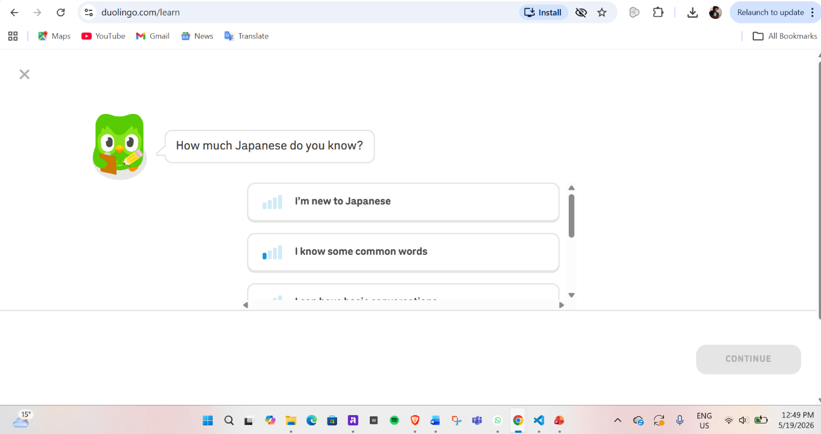
Icons and Buttons
The application uses large buttons, stars, shields, badges, and simple icons that are easy to understand. Rounded buttons and colorful visuals improve accessibility and make navigation easier for younger users.
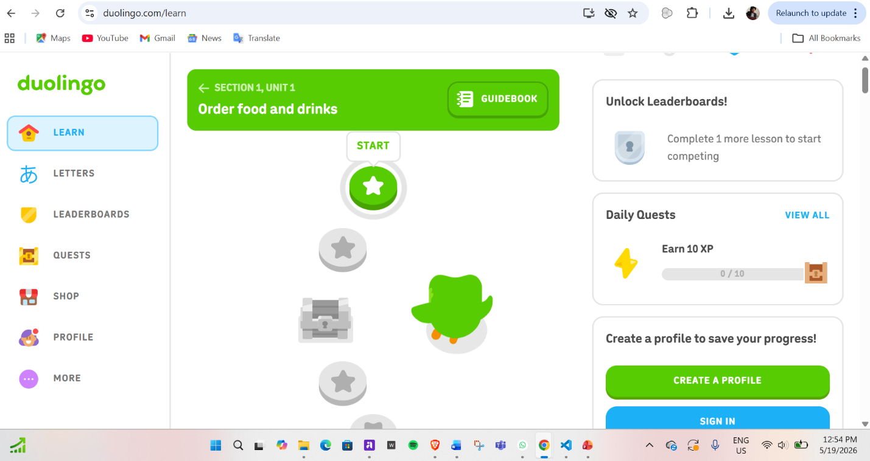
How It Holds Attention
Duolingo keeps users engaged using:
- streak systems
- XP points
- short learning sessions
- progress tracking
- positive motivational messages
The lessons are intentionally short to reduce boredom and encourage users to return daily.
Feedback and Reward System
The platform uses badges, unlockable rewards, celebratory animations, and encouraging feedback after each completed task. This creates a sense of achievement and motivates users to continue learning.
What We Will Apply to CybShield
From Duolingo, CybShield will apply:
- educational UX design
- motivation systems
- badges and XP rewards
- progress bars
- positive feedback messages
- simple readable layouts
- child-friendly colors and icons
These features will help make cybersecurity learning enjoyable for children aged 10–15.

2. Among Us UX Research
Target Users
Among Us is popular among users aged 10–25, especially children, teenagers, and young adults. The game focuses on teamwork, missions, and social interaction.
Colours and Backgrounds
Among Us uses dark navy and green futuristic backgrounds that create a space-themed environment. The high contrast between dark backgrounds and bright interactive elements helps important information stand out clearly.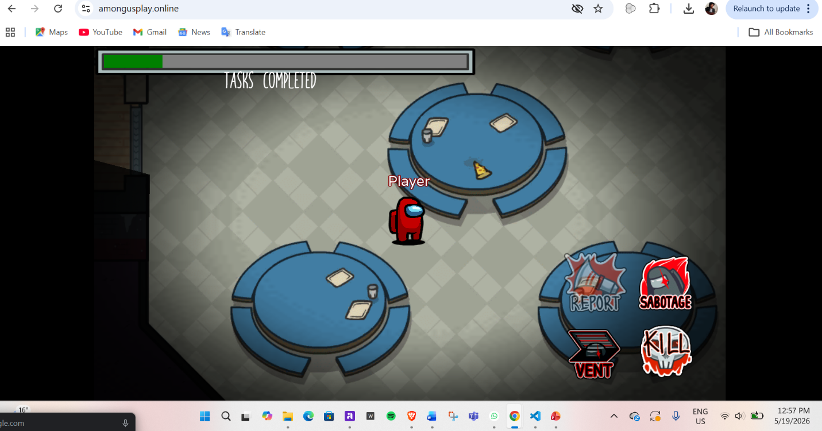
Icons and Buttons
The game uses bold and simple buttons with arrows, task indicators, and warning symbols. The interface is minimal and easy to understand, helping players quickly interact with tasks during gameplay.
How It Holds Attention
Among Us maintains player engagement through:
- suspense
- uncertainty
- mission-based gameplay
- fast interaction loops
- curiosity and problem-solving
Players remain interested because they constantly need to make decisions and complete objectives.
Feedback and Reward System
The game provides satisfaction through mission completion, social achievement, and successful teamwork. Completing tasks gives players a sense of progress and accomplishment.
What We Will Apply to CybShield
From Among Us, CybShield will apply:
- gameplay-driven learning
- mission-based challenge systems
- suspenseful cyber-safety scenarios
- interactive tasks
- futuristic cyber-themed backgrounds
- simple task-focused interface design
These features will help transform cybersecurity education into an interactive adventure rather than a traditional quiz.
Conclusion
The research showed that both Duolingo and Among Us successfully engage younger audiences through strong UX design principles. Duolingo provides inspiration for educational motivation and reward systems, while Among Us provides inspiration for interactive gameplay and mission design.
By combining these two styles, CybShield aims to create:
- a fun and engaging learning experience
- a safe and accessible interface
- motivating rewards and progression
- interactive cybersecurity missions for children aged 10–15
This combination will help users learn important cybersecurity concepts, such as two-factor authentication and online safety, in a way that feels enjoyable and memorable rather than educational or repetitive.

